Appendix 1

(Ref: Para. A5)

ROLES AND RESPONSIBILITIES – DIRECT AND ATTESTation COMPLIANCE ENGAGEMENTs

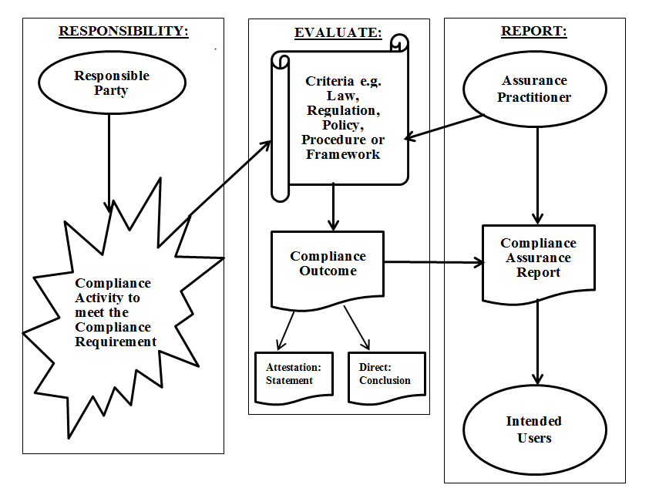The diagram below illustrates the relationships in a direct and attestation compliance engagement conducted by an Assurance Practitioner.

Under a direct engagement, the Assurance Practitioner evaluates the compliance activity conducted by the responsible party to meet the compliance requirement.

Under an attestation engagement, the Responsible Party evaluates the compliance activity against the compliance requirements and provides a statement on the compliance outcome.

In both attestation and direct engagements the Assurance Practitioner evaluates the compliance activity against the compliance requirement(s) using the criteria, and obtains assurance on which to base their assurance conclusion. The compliance assurance report is provided to the intended users.